# GOVERNMENT POLYTECHNIC COLLEGE MATTANNUR-670702

### (Department of Technical Education, Kerala)



**SEMINAR REPORT ON**

**MOBILE VIRTUAL REALITY**

**SUBMITTED BY SOORAJ K**

**(Reg.No:19041681)**

**DEPARTMENT OF ELECTRONICS ENGINEERING**

**2021-22**

**GOVERNMENT POLYTECHNIC COLLEGE MATTANNUR-670702**

**(Department of Technical Education, Kerala)**



**CERTIFICATE**

*Certified that seminar work entitled* “***MOBILE VIRTUAL REALITY*”***is a bonafide work carried out by* **“*SOORAJ K* ”** *in partial fulfilment for the award of Diploma in Electronics Engineering from Government Polytechnic College Mattannur during the academic year* 2021-2022.

### Seminar Co-ordinator Head of Section

**Internal Examiner External Examiner**

**DECLARATION**

I hereby declare that the report of *the* ***MOBILE VIRTUAL REALITY*** work entitled which is being submitted to the Govt. Polytechnic College Mattannur, in partial fulfilment of the requirement for the award **of *Diploma in Electronics Engineering*** *i*s a confide report of the work carried out by me. The material in this report has not been submitted to any institute for the award of any degree.

Place:Mattannur

Date: **SOORAJ K**

### ACKNOWLEDGEMENT

I would like to take this opportunity to extend my sincere thanks to people who helped me to make this seminar possible. This seminar will be incomplete without mentioning all the people who helped me to make itreal.

Firstly, I would like to thank GOD, almighty, our supreme guide, for bestowing his blessings upon me in my entire endeavor.

I would like to express my deepest gratitude **Mr. M C PRAKASHAN** (Principal GPTC, Mattannur), **Mr. GEORGE KUTTY P P (**Head of Department of Electronics Engg.), for the help rendered by him to prepare and present this Seminar in proper way. Moreover I am very much indebted to **Mr. SREEJITH A** (Lecturer, Electronics Engg, seminar co-ordinator), for their advice.

I am also indebted to all my friends and classmates who have given valuable suggestion and encouragement.

**SOORAJ K**

**ABSTRACT**

This paper addresses the capability needed in telecommunication system to support mobile access to real-time sights and sounds of a complex environment defined as a virtual reality service (VRS) episode. The constant development of terminal and networking equipment are paving way for the provision of a VRS and the creation of VRS episodes. This paper describes a mobile VRS environment in general and the core architecture and describes the various entities employed to perform a VRS episode setup task. The proposed VRS architecture is in full harmony with the preceding generation of all-IP multimedia networks currently under study in the third generation partnership project.

TABLE OF CONTENTS

**CHAPTERNO TOPICS PAGENO**

Chapter1 INTRODUCTION……………………………………...8

Chapter2 PROBLEM STATEMENT………………………….….9

Chapter3 SOLUTION………………………..……………….….12

Chapter4 VRS EPISODE..………….….. ………………….……13

Chapter4.1 ACTUAL PHYSICAL ENVIRONMENT…………….13

Chapter4.2 VRS USER EQUIPMENT………….………….……...13

Chapter4.3 VRS ACCESS SYSTEM………………..………….….13

Chapter4.4 VRS CORE SYSTEM…...………….………….……...14

Chapter5 GATEWAY ENTITY………………..….…………..…16

Chapter5.1 VRS IMPLEMENTATION SCENARIO….……….….16

Chapter6 VRS SYSTEM ARCHITECTURE AND CONFIGURATION…..…………………………..…....17

Chapter7 VRS EPISODE SETUP SIGNALING

INFORMATION FLOWS………………...…………..18

Chapter8 ADVANTAGES AND DISADVANTAGES……...…..21

Chapter8.1 ADVANTAGES……………………………………….21

Chapter8.2 DISADVANTAGES…….………….………….……...22

Chapter9 FURTURISTIC ASPECTS…………………………....24

Chapter10 CONCLUSION………………………………………..25

|  |  |  |
| --- | --- | --- |
| **FIGURE NO** | **LIST OF FIGURES**  **NAME** | **PAGE NO** |
| Fig 3.1 | A SCHEMATIC VIEW OF VRS FUNCTIONAL ARCHITECTURE............. | 12 |
| Fig 4.1 | A SCHEMATIC IMPLEMENTATION OF  VRS EPISODE SETUP………………......….. | 15 |
| Fig 7.1 | A VRS EPISODE SETUP INFORMATION | 20 |
|  |  |  |

**CHAPTER 1**

**INTRODUCTION**

A mobile virtual reality service (VRS) will make the presence and presentation of the sounds and sights of an actual physical environment virtually available everywhere in real time through the use of mobile telecommunication devices and networks. Furthermore, the VRS is the conversion of a physical system into its digital representation in a three-dimension (3D) multimedia format. This paper addresses one aspect of the notion of bringing an actual multimedia environment to its virtual presence everywhere in real time .An international telecommunication union (ITC) recommendation document, containing ITU’s visions on mostly forward-looking and innovative services and network capabilities, addresses the capability needed in a telecommunication system to allow mobile access to real-time sights and sounds of an actual physical environment in the contest and forms of a VRS episode .

Presently, the availability of a VRS is limited to fixed-access phenomena in non-real time , for example , entertainment machines and various simulations equipment. There are also some limited fixed-access and real-time services that require low data transmission rates, such as net meetings. In the latter case, a user can experience a limited real-life environment as opposed to the former case of a non-real-life computer-generated environment. These existing virtual reality services do not allow user control in viewing 3D environments, and they are generally limited to viewing images on a monitor in two dimensions. The VRS-capable systems, however, will allow rather 3D representations of remote real-life environments. For instance, a passenger in a train or in a car could become a participant in a conference call in a 3D environment or become virtually present among the audience in a concert hall or sports stadium viewing a live concert or event.

There are a few obstacles and bottlenecks to the realization of such VRS-capable systems. The development of real-time mobile 3Denvironments requires:

• Super-high-speed data transmission rate capability for data streaming.

• Highly complex and sophisticated user equipment for user access, and

• An advanced signaling and controlling data network.

The advanced signaling and controlling data network is for initiating, establishing, maintaining, and terminating VRS episodes. Exponential increases in data transmission rates and innovative advances in development of terminal equipment are paying the way for the provision of the VRS and the creation of VRS episodes in the near future. Furthermore,the realization of the VRS assumes that the high-tech industry will deliver super high data rate(SHDR) transmission equipment offering a transmission speed of equal to or higher than one gigabit per second to a single user or end point . The anticipated demand for data transmission speed in 2005 will be higher than 20 M/s, upgraded from today’s third-generation planned 2 Mb/s. the transmission speed requirements for the so-called fourth generation systems in 2007 are expected to reach near 100 Mb/s. At these rates, telecommunication equipment should be able to transmit, transport, and receive sights and sounds of real-life environment for establishing a VRS episode.

The development of the core signaling and controlling network and its associated software platforms for VRS episode control and for terminal and enduser equipment mobility management is viewed as a major challenge in terms of its control logic and its application programming interfaces for provisioning of the VRS. This paper addresses the core network sub-system for VRS episode control. Several VRS use cases are presented first, and major issues for realization of the VRS are identified. The paper then proposes a solution scheme for the core network signaling and the VRS episode control. The final section of the paper describes an implementation scenario along with an example of signaling flows for establishing and controlling episodes.

**CHAPTER 2**

**PROBLEM STATEMENT**

From a users perspective, the VRS is defined as the experience of viewing an object in its 3D environment and sensing its sound with its natural and real-world quality. By limiting the VRS to sight and sound, it is meant to disclaim creation of any other aspects of an actual physical environment, for example, smell of a flower or taste of a food. A few examples of the VRS is listed below:

• A virtual conference session depicting to every participant the presences of others in a virtual conference room with projector screen, drawing board, and so on.

• A virtual movie theaters where a user can view movies with the same feel as being in a movie theater.

• A virtual hospital operation room (OR) where a surgeon can remotely perform an actual operation and/or provide training to assistant surgeons and interns by showing and/or performing actual procedures.

• A virtual concert hall where a conductor can have the virtual presence of all, or a selective number of instruments players participating from all over the world for a rehearsal or actual performance.

• A virtual house, shop, or storage facility where a user can do a security check, identify product availability, or determine inventory levels of various items, respectively.

• A virtual command center for navigating an aircraft, driving a train, or operating a motor vehicle where the virtual environment is created for the cockpit, the locomotive, or the driver’s seat respectively.

• From a network operator’s perspective, the provision of the VRS is the conversion of the sights and sound of an actual physical system into their virtual representation.

For each required case and application, the development of the software platforms for the control and the management of the VRS and in terms of its control logic and application-programming interface is a major challenge. The VRS will include both terminal and personal mobility. It could be a set up in a limousine, hotel, airport, home or office. Depending on the type and complexity of the actual system, the estimate for required data transmission rates varies from a minimum of tens of Megabits to a few Gigabits per user or user equipment.

Currently, the availability of the VRS is limited to fixed application s in noon-real time, for example, entertainment machines and flight simulators. Some limited feature- fixed real-time services such as video-conferencing and net meetings, which require low data transmission rates, are also offered. However, the mobile, wireless, and real-time accessed sights and their virtual reality presence are still dreams. Major obstacles and bottlenecks to the achievement of such an ambitious goal include:

• Lack of VRS-capable user terminal equipment.

• Inadequate data transmission rates over the air, and

• Absence of efficient and suitable signaling and controlling network elements for initialing, establishing, maintaining and terminating mobile VRS episode.

The section below addresses the signaling and controlling part of the solution, and proposes a VRS provisioning solution scheme by focusing on the core signaling and controlling network including a high level view of the signaling network architecture and its controlling functional entities. An under lying assumption for this proposed solution is that the high-tech industry will deliver the required SHDR radio transmission capability along with VRS capable equipment.

Expectedly, the ongoing development activities on the optical capacity problems and the tripling antenna project will find their way into mobile telecommunication equipments in the near future and will alleviate some of the critical bandwidth problem. The requirements for mobile terminal equipment and the radio access network to meet the spectrum and data transmission speed requirements are beyond this section. Furthermore, this services capability may also be restricted in terms of mobility. In its early phases of development, the wireless SHDR transmission capability may be limited to slow-moving terminal equipment. Increases in the data rate in the post-IMT-2000 era could expectedly reach 100Mb/s for indoor access. The proposed solution describes a mobile VRS environment in general and its core network for signaling and controlling of a VRS episode in specific. It presents an overview of the VRS architecture and describes the various entities to perform the task of VRS provisioning .The VRS functional architecture is proposed in full harmony with preceding generations of all-IP multimedia core network functional architectures currently under study and development in the third- Generation partnership project.

**CHAPTER 3**

**SOLUTION**

The VRS realization scheme is built upon the development and availability of the following entities:

• Actual physical environment (APE)

• VRS user equipment (VUE)

• VRS access system (VAS) and

• VRS core system (VCS).

The figure presents a schematic view of these entities in a high-level illustration of the VRS functional architecture. In order to describe the VRS realization scheme, its functional architecture, and its components, definition of the following terms is needed.

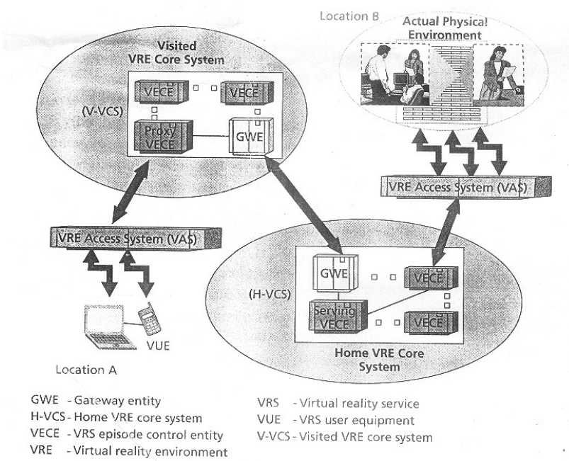

Fig 3.1 A schematic view of VRS functional architecture

**CHAPTER 4**

**VRS EPISODES**

A VRS episode is defined as the real-time establishment of sights and sounds steaming communication between one or more VRS users and sites. As a call is the establishment of communication between users in a voice network, and a session is a establishment of communication among severs and client in an IP multimedia network,aVRS episode is the establishment of a collection of calls and/or sessions in a multimedia super-high-capacity virtual reality environment.

**4.1 Actual physical environment**

An actual physical environment (APE) is the real world environment of the subject to be presented (through sight and sound) to one or more VRS users or user equipment. Furthermore, it is the actual subject environment that is transmitted to and audio visually formed in a virtual environment.

**4.2 VRS user equipment**

VRS user terminal equipment (VUE) is the end-point device used by a user to transmit data on an APE and/or to receive data for establishing a VRS episode. The VUE can be in the shape and content of a toolkit such as a single handset, a headset, a helmet, a pair of gloves, a desk, a chair, a keyboard, a mouse, a screen, a video camera, or a recording device. It could also consist of any combination of these toolkits. The VUE is primarily a software-driven device and is controlled and/or manned by one or more users, network or both. An example of the VUE may be a setup similar to today’s T1connection using two pairs of normal twisted wires, the same as one would find in a house or in a private booth. The use this VUE device is essential for both creation and provisioning of desired VRS episodes related to various applications. Another example of the VUE could be the equipment used by a head surgeon in his office environment to remotely guide a group of assistant surgeons performing a surgical procedure in a hospital.

**4.3 VRS access system**

the VRS access system (VAS) is the intermediate VRS-capable system linking theVUE to the VRS core network system. It is a fix terrestrial or satellite radio access system that provides the mobile VUE with an access to the VRS.

**4.4 VRS core system**

The VRS core system (VCS) is the controlling backbone network that, in conjunction with the VUE and VAS, manages the establishment of VRS episodes. Depending on the number of VUEs and APEs being used, there could be more than one VCS system involved in establishing a VRS episode. Building upon the session control schemes defined in 3GPP and 3GPP2 standards, the VCS supports many of the homeand-visited concepts that have already been environment in the third generation standards. A visited VCS (V-VCS) for a VUE is the core network system to which the VUE us attached. A VCS is labeled as the home VCS (H-VCS) to a VUE if the user has the subscription affiliation with the VCS.

A VCS, either home or visited, that is in charge of establishing and managing a VRS episode is called a serving VCS (S-VCS). The two home and visited VCS types are shown in figure 1.A VCS system contain, in addition to other entities, three key VRS functional entities are described below. These functional entities are in addition to other entities and resource functions that may be present in a VRS for the purpose of establishing VRS episodes as well as supporting other services such as second generation calls, third-generation multimedia sessions, third-party value-added services providers. VRS episode control entity. A VRS episode control entity (VECE) is a functional entity in change of supporting and/or controlling a VRS episode. In a VRS episode there are two basic types of VECE for a VUE. They are the proxy VECE and the serving VECE. At the time of VUE’s registration with a visited VCS network, a VECE in the visited VC, labeled as a P-VECE is assigned to attend and monitor all requests coming from or going to the VUE. The S-VECE is a VECE in the serving network in charge of controlling the VRS episodes and keeping track of the VUE status. There is a 1-to-n correspondence between the VECE and VUE. During the time that a VRS episode is in progress, the P-VECE does not necessarily remain the same. Depending on the mobility range of the VUE, a handover of the VUE may be performed among several P-VECEs. However, the S-VECE for a VUE remains the same throughout a VRS episode. In figure 1, the S-VECE represents the serving VECE that is located in the H_VCS is the S-VCS as well. This special handover feature is similar to the session mobility in third generation networks.

VRS episodes management entity. For a VRS episode, there could be more than one VRS system. A VRS episode may involve a number of VUEs and APEs from a number of geographical positions and with a wide mobility range. Each VUE may be connected to a separate VCS through A separate P-VECE and served by an S_VECE and served by an S-VECE. Furthermore, for a VRS episode, there could be a number of S_VECEs to interact, synchronize, andcoordinate.AVRS episode management entity (VEME)is a functional entity that manages a number of S-VECEs for a VRS episode . As such, it coordinates, synchronizes, and maintains all the communications between all S-VECEs for a VRS episode. In a physical implementation, a VEME may be defined as a multimedia management, control, and operations center interfacing with the S_VECE of each VUE participating in a VRS episode. The VEME may be residing in a V_VCS or S-VCS and co-located with a VECE box or in a separate box. The VEME service may be offered by the third-party application server, which makes use of its underlying VCS capabilities. In such a case, the VEME could be an entity residing either in an independent external platform operated by the third-party service provider.

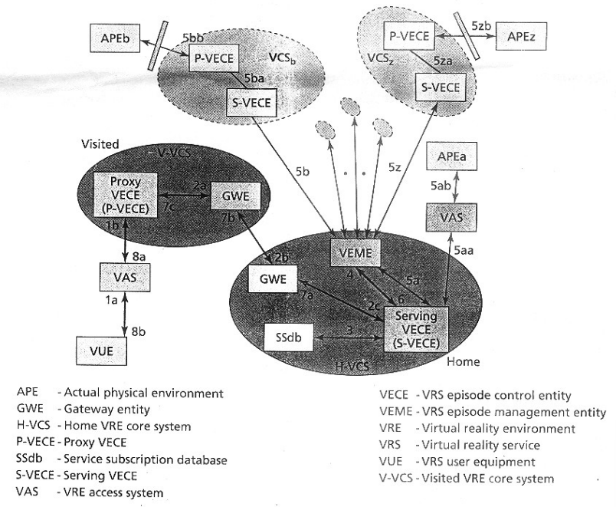

Fig 4.1 A schematic implementation of VRS episode setup

**CHAPTER 5**

**GATEWAY ENTITY**

The gateway entity (GWE) is a boundary functional entity with each VCS. It is the connecting point of all VECEs in a VCS network from one side and the GWE of another VCS from the other side. It is the point of entry and exit for all VRS episode control signaling message follows to and from a VCS, respectively.

In addition, the GWE plays the role of a firewall, hides the structure of its underlying network, and facilities the flow and routing of the VRS signaling traffic. Figure 2 also shows the instance of two GWEs for a hypothetical VRS episode.

**5.1 VRS implementation scenario**

This section presents an example of the VRS architecture, a configuration scenario for a single VUE and multiple APEs participating in a VRS episode setup and the management of its signaling flows.

**CHAPTER 6**

**VRS SYSTEM ARCHITECTURE AND CONFIGUATIONS**

Figure 4.1 presents a schematic implementation of the VRS functional architecture with two primary VCS subsystems, home and visited, for one VUE and several secondary VCS subsystems, each serving one or more APEs. The example in Figure2 shows only one VUE. However, it could be expanded to include multiple VUEs participating in a single VRS episode. The figure presents a configuration example for establishing a VRS episode. Each arrow in the figure corresponds to a signaling message exchange requesting an action or responding to a request.

The VUE is the user equipment initiating a VRS episode setup. The VUE is visiting a network where the P-VECE is its first point of entry into the core network system, a visited V-VCS. For ease of illustration, in this example the H-VCS of the VUE is assumed and shown to be the same as the S-VCS. Therefore, the S-VECE is located in the VUE’s home network. In addition, in this configuration example the VRS episode management entity VEME is assumed to be located in the VCE’s home network.

The actual physical environment (APE) endpoints are shown as scattered globally across many VCS systems. Flows 5a through5z in figure 2 represents the interactions between the VEME and the S-VECE of various endpoints. The access systems for these endpoints may include fixed and/ or mobile systems.

**CHAPTER 7**

**VRS EPISODE SETUP SIGNALING INFORMATION FLOWS**

Figure 5.1 presents the signaling information flows for the procedure to involve and setup a VRS episode based on the configuration shown in figure 2. To keep the figure form being cluttered, a sunny day scenario is assumed and no protocol response action is shown in this figure. Each double-headed arrow in figure 2 corresponds to two message flows or transaction, a request message and a response message. The response message could be simply a protocol response to a request message, acknowledging the request or sending an error message. A brief description of each signaling message flow is given below.

After the VUE’s attachment to, and registration with, the visited VCS(VVCS),and at ground zero, a stimulus flow initiates the procedure for setting up a VRS episode. This is similar to today’s procedure for a 3G-user equipment (UE) procedure for registration with a 3G-multimedia mobile network. Furthermore, it is assumed that the VUE had already been registered with a visited VRS-capable VCS system. This flow is a request by a user to setup a VRS episode and it could be done via an automatic setup or a manually activated request. As a result of this registration procedure, a proxy VECE and a serving VECE are assigned to the registered VUE.

1.(1a and 1b) Initiating the request for establishing a VRS episode to the network via an intermediate access subsystem, the VRS user equipment (VUE) sends a VRS episode request to its service attendant, the P-VECE in the visited VCS network. Parallels may be drawn between these episode request messages and the session invite messages of the sip.

2. (2a, 2b,and2c) Upon recognizing the request for establishing a VRS episode , the service attendant P-VECE, acting as a proxy VECE for the VUE, forwards the VRS episode setup request via the gateway entities (GWEs) in VVCS and H-VCS to the S-VECE that is the serving service attendant in the VUE’s home network.

3. [Sub-routine]: The S-VECE sends n information query to the VUE’s service subscription database (SSdb) for the VRS service information, eg, service parameters, service authorization

4. Recognizing the request for establishing a VRS episode, the S-VECE, after inquiring information on VUE’s subscription profile for service eligibility, sends a request for a VRS episode setup to the VEME. For ease of illustration, the S-VECE’s interaction with other entities in the network for verification of the VUE’s service eligibility, authentication, and service authorization are not shown here.

5. [Sub-routine]: Using information on the VUE’s VRS subscription, the VEME identifies all end-points involved in the VRS, and dispatches notification requests for the VRS episode setup to various S-VECEs of the actual physical environment (APE) endpoints including those in theVUE’s home network (if any ), e.g., APE. Each SVECE,acting on the request from the VECE,sends a request to the corresponding P-VECE each APE. In this example, one VUE and several APEs were assumed to be participating in the VRS episode setup as the episode endpoints, originating point and terminating points, respectively.

6. Once all would be participants in the VRS episode have been identified and/or alerted, and affirmative responses have been received by the VEME, the VEME responds positively to the VUE’s S-VECE.

7. (7a, 7b,and7c) The S-VECE forwards the episode response message to the VUE’sE in the visited network, the V-VCS.

8. (8aand8b)The P-VECE,in turn, forwards the response message to the VUE.

9. [Sub-routine]: At this point, all necessary protocol acknowledgment and notification have been received. The next move is to have all needed bearers for media transport established and to have the VRS episode setup for the specific VRS delivery.

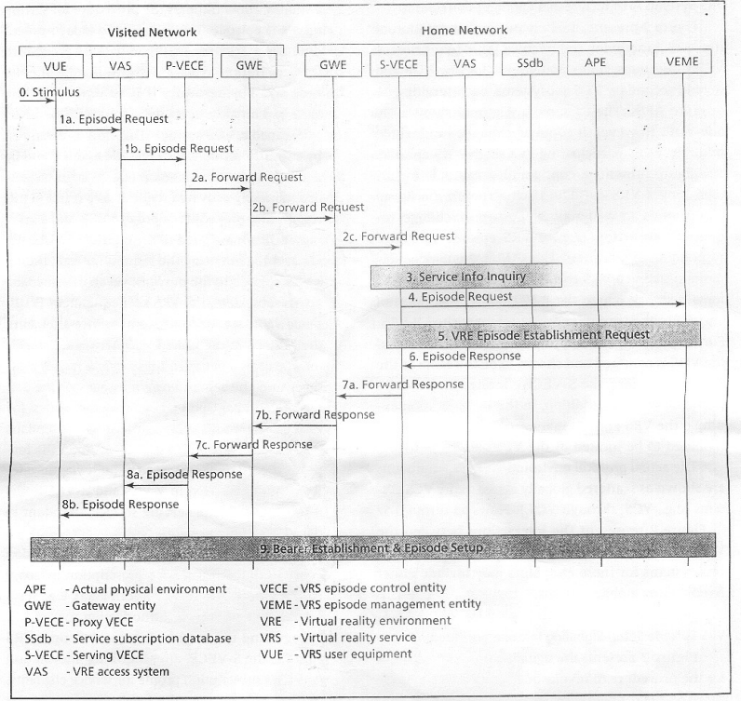

Fig 7.1 A VRS episode setup information flow diagram

**CHAPTER 8**

**ADVANTAGES AND DISADVANTAGES**

## 8.1 Advantages of Virtual Reality

### 1. Recovery and Healing

The method of this concept is Virtual Reality is useful for army veterans and soldiers with [PTSD](https://www.bbc.com/news/uk-wales-49880915). The simulations help the military patients by matching the actual circumstances and enabling them to tolerate disabling stressors. Virtual Reality also helps them reduce phobias by allowing them to understand the fearful environment better. VR is also helpful for patients to enhance their motor skills and physical rehabilitation process.

### 2. A Real-time educational experience

VR helps students and professionals remodel the complicated tasks and projects which are even difficult to understand in real life. It’s not like Virtual Reality is just made for fun and entertainment, VR is also one such tool for [medical practitioners](https://www.ncbi.nlm.nih.gov/pubmed/10172193) and surgeons where they can understand the anatomical structure. VR also makes it pretty much safer for the aviation and automobile industry. Pilots are given training through simulations so they can avoid mishaps, and aspired drivers are also trained through VR for the same reasons.

### 3. VR is the way to explore places

In this world evolving technology, VR is a boon to every tech lover. Virtual Reality helps us to explore many places around the globe, just staying in one place. Now, imagine if you want to visit a place sitting on your couch, VR enables you to tour that destination without any cost. The real view will give you an overview of the site for which you can plan a trip later.

### 4. VR Opens the world of Entertainment

It is needless to say what great amusement VR can bring you while staying at home. The 3-D visuals are merely an example to give you a thrilling experience of all the gaming world and live sports. That’s not all; you can enjoy some breath-taking sports like Bungee jumping, skydiving, and racing. So sit tight at home and get prepped up for adrenaline rush.

### 5. Engagement and Interaction

Through virtual reality headsets, it is easier to communicate with your peers inside the virtual reality spaces. As this technology is at its peak, you'll never be away from meeting new friends. Thus, Virtual Reality opens many windows for you to be interactive and open to others where you can share your experiences with the other people connected through Social media. What a way to hang out with your friends through virtual reality? Social media platforms through virtual reality are enough to turn your previous experiences upside down.

## 8.2 Disadvantages

### 1. Virtual Reality Isolates you in Real Life

Let’s face the ultimate fact capable enough to help us understand what lies ahead of Virtual Reality. The more time spent in the virtual world, the more isolated one would feel. Being less friendly in society means you would have to struggle to express yourself publically and in private life. As a human, an ideal relationship between humans is developed through interpersonal connections. Be it your family or friends, dangers of Virtual Reality lurk around in the form of disconnecting you entirely from the real world.

### 2. VR Might Cause Eye Strain

Let's talk in terms of health now, which is also quite distressing to eyes. VR headsets are the closest to your eyes that contain two small LCD monitors, projected at both eyes. Thence, putting you at risk of multiple eye disorders, VR headsets, if used for long periods, can lead to the most common problem, which is [Eye strain](https://www.essilorusa.com/newsroom/is-vr-bad-for-your-eyes). It occurs due to focusing on one object for an extended period, as in watching a long movie or staring at your computer or smartphone all day.

### 3. Limited Educational Flexibility

If a class depends solely on a software-based simulation, this deteriorates the mental capacity and flexibility of students. The verbal interaction reduces between instructors and students where answers are predetermined, and no cross-questions are put up. When both the teacher and students are following programmed instructions and guidelines, the real-time interaction reaches its detrimental state. One should keep in mind that education can't stay limited to programmed software only.

### 4. Virtual Reality Can be Glitchy

A machine is a machine that can falter at any time and moment. A programmed software can go wrong any minute, which is cumbersome for all types of users, whether students or gamers. Fixing or patching the fault may take time and also cost you more than usual. Now, assume you have a test the next morning, and your headset goes dysfunctional at the 11th hour.

### 5. VR is Addictive like drug

Users who have VR headsets already will most possibly understand the pain of going through this addiction. As you spend more into the real world, this not only cuts you from reality but also makes you addicted to VR. You’ll never know how many hours you have piled up playing your video games and how much time you have wasted already. You should remind yourself that it is not happening in actual; it is all virtual. It is time to come back to reality.

**CHAPTER 10**

**CONCLUSION**

This paper describes the concept of the VRS and the telecommunication environment for its realization .It identified major challenges for its realization. It calls for an SHDR transmission capability for the end-user equipment and networks. Assuming the availability of an SHDR transmission capability for the end-user equipment and networks, an example of the VRS system architecture was presented, and a systematic approach was proposed for a VRS implementation scenario. It illustrated a VRS control scheme and described the signaling information flows for setting up a VRS episode. This paper neither proposes the use of any specific transport or control protocols for implementation of the required tasks, nor does it restrict the use of any specific standard protocol. A number of presently available protocols may be revised and enhanced foe initiating, establishing, and controlling VRS episode.

**CHAPTER 11**

**REFERNCE**

1. International Telecommunication Union-Telecommunication standardization Sector 9ITU-T), “long term vision network Aspects for system beyond IMT-2002”

2. 3 rd Generation partnership project, IP multimedia (IM) subsystem stage.

3. F.Battaglia and P-w.Ong , “Information Access on the Go-with ilife case study”. Murray hill Wireless seminar series, bell laboratories, lucent technologies.

4.<https://www.igi-global.com/dictionary/mobile-virtual-reality-to-enhance-subjective-well-being/60656>

5. M .Grech,M.torabi,and M. Unmehopa , “service control architecture in the UMTS IP Multimedia core network subsystem”.

6. [www.interscience.wiley.com](http://www.interscience.wiley.com)